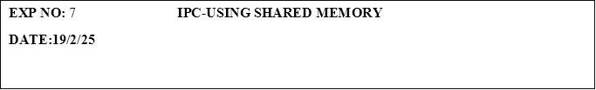

**PROGRAM:**

**Sender.c**

#include <stdio.h>

#include <stdlib.h>

#include <sys/ipc.h>

#include <sys/shm.h>

#include <unistd.h>

int main() {

    key_t key = ftok("shmfile", 65); // Create a unique key for shared memory

    int shmid = shmget(key, 1024, 0666 | IPC_CREAT); // Allocate shared memory segment

    char *message = (char*) shmat(shmid, NULL, 0); // Attach shared memory segment

    // Writing a message to shared memory

    sprintf(message, "Welcome to Shared Memory");

    // Set a delay

    sleep(2);

    printf("Message Sent: %s\n", message);

    // Detach the shared memory segment

    shmdt(message);

    return 0;

}

**receiver.c**

#include <stdio.h>

#include <stdlib.h>

#include <sys/ipc.h>

#include <sys/shm.h>

int main() {

    key_t key = ftok("shmfile", 65); // Create a unique key for shared memory

    int shmid = shmget(key, 1024, 0666); // Get the shared memory segment

    char *message = (char*) shmat(shmid, NULL, 0); // Attach shared memory segment

    // Print the message received from the shared memory

    printf("Message Received: %s\n", message);

    // Detach the shared memory segment

    shmdt(message);

    // Remove the shared memory segment

    shmctl(shmid, IPC_RMID, NULL);

    return 0;

}

**OUTPUT:**

Message Sent: Welcome to Shared Memory.

Message Received: Welcome to Shared Memory.